Views of the European Network on Inclusive Education & Disability on the European Disability Forum’s Proposal for a European Mobility Card
25.03.2015
The European Network on Inclusive Education & Disability, incluD-ed, supports the European Disability Forum’s (EDF) proposal to introduce a European Mobility Card.
In May 2011, the EDF presented a “Proposal for a European Mobility Card” within the framework of its Top Campaign 2011 on the theme of “Freedom of Movement” to facilitate the travel and stay of people with disabilities in another EU Member State (EU MS) by granting them access to the same services as residents with disabilities in that country.
incluD-ed prepared this position paper knowing that the possibility of an EU Mobility Card is currently being discussed. An EU Mobility Card would be especially important to improve the education and working situation of young people with disabilities in the EU.

incluD-ed underlines that the introduction of a European Mobility Card is
- important for inclusive education.
- important to achieve EU2020 objectives.
Actions needed:
- Concrete proposal for a European Mobility Card by the new European Commission.
- Education should be incluD-ed as an essential element of the European Mobility Card.
Article 26 of the EU Charter of Fundamental Rights provides all EU citizens the right to freedom of movement. About 83 million EU citizens have some kind of disability and have faced until today obstacles to fully enjoying their right to freedom of movement. While in their home countries, people with disabilities can enjoy certain benefits “which facilitate their mobility and inclusion in all areas of social, economic and cultural life [...] these benefits cannot be transferred when travelling to another EU MS […] The mutual recognition of existing disability cards and related entitlements, or the introduction of a European Disability Card with certain rights linked to it, would be appropriate measures to remedy this“ and to ensure that the Europe 2020 Strategy objectives will be achieved.
incluD-ed, following its mission to promote equal opportunities in the educational context, with the aim of improving employability and work inclusion for people with disabilities, underlines that the portability of disability benefits is essential for people with disabilities who want to work or study in another EU MS. In November 2013, EU Justice Commissioner Viviane Reding communicated that the European Commission initiated a project working group to discuss with EU MS and civil society representatives the practical details of issuing and managing a European model disability card.

Knowing about the current discussion of the possibility of an EU Mobility Card, incluD-ed would like to express its opinion:
- incluD-ed welcomes recent actions undertaken by the European Commission (EC), in particular the creation of the project working group working on details of a future EU Mobility Card.
- incluD-ed welcomes that the card “is likely to grant benefits in the areas of culture, leisure, sport, transport and tourism”, important areas for people with disabilities studying and working abroad.
- incluD-ed asks to explicitly include education in the scope of the EU Mobility Card
incluD-ed regrets that the right to ‘Freedom of Movement’ has still not been fully achieved for people with disabilities
- incluD-ed believes that the right to ‘Freedom of Movement’ is a core principle of the EU, enabling “EU citizens to work, establish themselves, study and travel abroad and to have easy access to goods and services in any Member State”.
- Already in 2010, the European Economic and Social Committee nevertheless drew attention to the fact that the “freedom of movement […] has not been fully achieved for people with disabilities” and asked in its EESC opinion on the European Disability Strategy 2010-2020 for the creation of a EU Mobility Card as a concrete and effective tool towards a barrier-free Europe.
- Barriers that prevent people with disabilities from making full use of their right are diverse, and include no access to the physical environment and to communication; legislative and administrative barriers; and the non-recognition of their disability status in another EU MS.

incluD-ed calls on the EC, the European Parliament and EU MS to make a timely introduction of an EU Mobility Card
- incluD-ed underlines that people with disabilities are dissuaded or even prevented from studying or working abroad because of the non-recognition of their disability status in another EU MS.
- incluD-ed therefore supports EDF’s proposal to adopt a “European Mobility Card based on the principle of mutual recognition of existing national disability cards”.

incluD-ed calls on the EC, EU MS and stakeholders involved in the negotiation process at regional, national and European level to a timely agreement on a model of an EU Mobility Card.
incluD-ed calls on the EC, the European Parliament and EU MS to foster equal opportunities for people with disabilities via an EU Mobility Card
- incluD-ed believes that an EU Mobility Card fosters equal opportunities for people with disabilities especially in regards to education, training and employment opportunities the EU offers to its citizens.

incluD-ed believes that the chance to work, study and travel abroad not only significantly increases the quality of education and facilitates integration into the labour market, but is also crucial “for the social integration of people with disabilities” within the EU.
incluD-ed believes that a EU Mobility Card will help to realise EU2020 goals
- incluD-ed believes that the Europe 2020 Strategy will only be successful if “structural improvements as regards the mobility and inclusion of people with disabilities” are made.
- incluD-ed stresses in this regard the need to make the education and training systems more accessible and inclusive for people with disabilities. The EU, plus a majority of its MS, have ratified the Convention on the Rights of Persons with Disabilities (UNCRPD) that requires the development of an inclusive education system for all, and at all levels (Art. 24) and states that the labour market and work environment need to be open, inclusive and accessible (Art. 27).
- incluD-ed believes the introduction of an EU Mobility Card would represent an appropriate legislative step to comply with the UN CRPD.

incluD-ed states that there are no legal barriers towards adopting an EU Mobility Card
- EDF outlined in its report “Towards a European Mobility Card” that when traveling for business, education or personal reasons national disability cards (if existing) are generally no longer valid, as the format and language differ. “The only nationally issued disability-related card that is recognized throughout the EU today is the parking badge for people with disabilities”.
- EESC in its opinion on the European Disability Strategy 2010-2020 stressed the importance of a EU Mobility Card to ensure the right to freedom of movement for persons with disabilities.
- incluD-ed calls on the EC to use the EU parking badge scheme as best practice for an EU Mobility Card as it has no additional administrative burdens on host MS and maintains EU MS autonomy.
- incluD-ed strongly believes that there are no legal barriers towards adopting an EU Mobility Card, provided it is based on a EC recommendation on mutual recognition and that each EU MS and/or service provider decides what rights/entitlements for their residents with disabilities should be linked to it, and who is entitled to receive the card.

incluD-ed underlines the need to cope with the practical challenges of an EU Mobility Card
- incluD-ed supports EDF’s idea that the EU Mobility Card should have a harmonized design, providing “information on the kind and degree of impairment” in the main EU languages as used on EU ID cards and in Braille. It can complement or replace national cards.
- incluD-ed welcomes the proposal that the EU Mobility Card provides “upon simple presentation” access to the same benefits and entitlements that people with disabilities of the host countries have – except “benefits related to social security, social assistance and fiscal benefits”.
- incluD-ed underlines that when studying or working uproad, it is important for people with disabilities to benefit from “free or reduced rates for various services, or the right to access these services with an accompanying person at no additional cost” such as public transport, cultural and sportive events, and other services for people with disabilities provided by the public or private sector.
- incluD-ed encourages the EC to develop a complementary accessible website or website area in already existing EU online portals, such as the EU Job Mobility Portal (EURES) where information about the benefits available in different countries could be found, “facilitating the cross-border movement of persons with disabilities via an improved information system on their rights and possibilities, and the conditions”.

incluD-ed asks the new European Commission to put forward a proposal on an EU Mobility Card
- incluD-ed asks the new EC, the European Parliament and EU MS to establish an EU Mobility Card providing “mutual recognition of disability status and thereby facilitating free movement of persons with disabilities in the EU”.
- incluD-ed calls on the EC and EU MS to strongly promote in a further step the EU Mobility Card system in order to be well known and widely recognised as a proof of disability status.

incluD-ed believes that the timely introduction of the EU Mobility Card will lead to a greater and more sustainable social cohesion in Europe through education and allow Ppeople with disabilities to better participate in society and the labour market.

Notes to the editors: The European Network on Inclusive Education & Disability (incluD-ed) is a collaborative and multi-stakeholder initiative with two primary goals: 1) to promote, identify, disseminate and exchange good practices and all types of resources related to inclusive education for people with disabilities across Europe; and 2) to influence EU and national policies and to encourage an active and inclusive focus in education systems.

incluD-ed understands that equal opportunities and inclusive education are key factors for employability, work integration and social inclusion.

incluD-ed is promoted by Fundación ONCE and co-funded by the European Social Fund in the framework of the Operational Programme ‘Fight Against Discrimination 2007–2013’. Fundación ONCE works in collaboration with three other founding partners and incluD-ed will run until 2015.

Currently, its member organisation, as founding partners together with Fundación ONCE are: Association des Paralysés de France (APF), Kynnys ry in Finland, and Rytmus in the Czech Republic. In Local Promoting Groups (LPGs) in European cities, the network comprises local authorities, schools, universities, companies, public services, local associations, experts and other stakeholders who work together to promote initiatives in the areas of inclusive education and disability.

Founding partners:

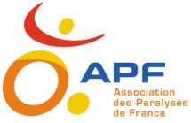
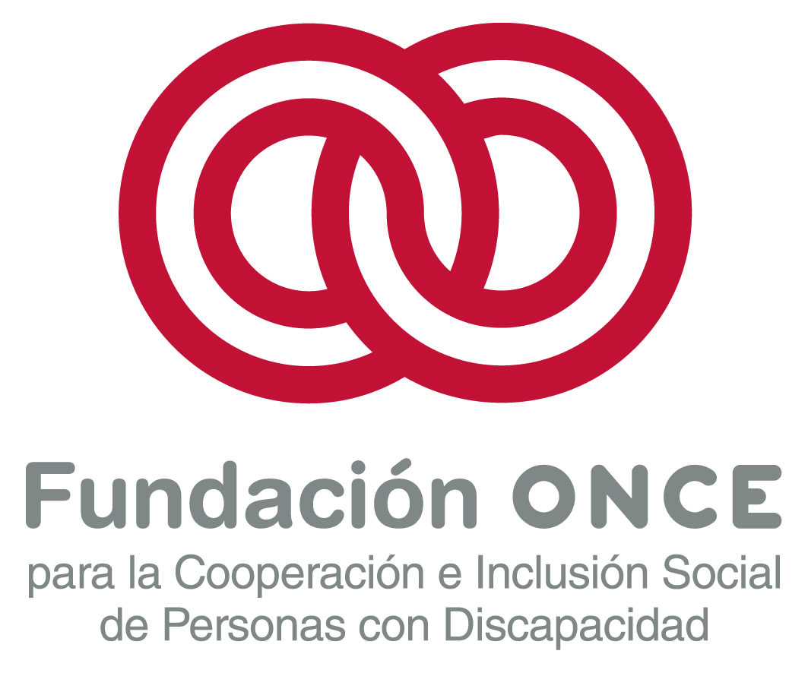
Since September 2013, the network has incorporated six Associated Members from different European countries: queraum. cultural & social research - Austria; FIRAH (International Foundation of Applied Disability Research) - France; University of Akureyri - Iceland; Inclusion Ireland - Ireland; Association RENINCO - Romania; Centre for Studies on Inclusive Education (CSIE) - United Kingdom.

Website: www.incluD-ed.eu

European Parliament (EP) (2013): Matthias Groote. Parliamentary question P-011810-13. Subject: European Mobility Card/ European Disability Strategy 2010-2020. URL: http://www.europarl.europa.eu/sides/getDoc.do?type=WQ&reference=P-2013-011810&language=RO
European Commission (EC) (2013): Parliamentary question P-011810/2013. Answer given by Mrs Reding on behalf of the Commission. URL: http://www.europarl.europa.eu/sides/getAllAnswers.do?reference=P-2013-011810&language=RO
European Disability Forum (EDF) (2011): Freedom of Movement campaign. In: Pen Citizenship. EU Mobility. ISSUE 2.2 WINTER 2011. (p.105).URL: http://www.opencitizenship.eu/ojs/index.php/opencitizenship/issue/view/2
European Economic and Social Committee (EESC) (2010): OPINION of the European Economic and Social Committee on People with disabilities: employment and accessibility by stages for people with disabilities in the EU. Post-2010 Lisbon Strategy (exploratory opinion). Rapporteur: Mr Cabra de Luna. (p.8)URL: http://www.eesc.europa.eu/?i=portal.en.soc-opinions.14185
EESC (2011): EESC opinion: European Disability Strategy 2010-2020. URL: http://www.eesc.europa.eu/?i=portal.en.soc-opinions.14946
EDF 2011, p.105
European Parliament (EP 2011): REPORT on mobility and inclusion of people with disabilities and the European Disability Strategy 2010-2020, p.15. URL: http://www.europarl.europa.eu/sides/getDoc.do?type=REPORT&reference=A7-2011-0263&language=EN
EP 2011, p.6
EDF 2011, p.3
EESC (2011): EESC opinion: European Disability Strategy 2010-2020. URL: http://www.eesc.europa.eu/?i=portal.en.soc-opinions.14946
European Disability Forum (EDF) (2012): EDF Analysis Report – Towards a European Mobility Card, p.21, URL: http://www.edf-feph.org/Page.asp?docid=29753&langue=EN
EDF 2011, p.4
EDF 2012, p.33
EDF 2011, p.8
Ibid.
European Disability Forum (EDF) (2012): EDF Analysis Report – Towards a European Mobility Card (p.31). URL: http://www.edf-feph.org/Page.asp?docid=29753&langue=EN

